Methodology 2. System drought indicator for users with complex supply portfolios

*Authors: Alvar Escriva-Bou, Michael Dettinger, Jeff Mount…*

# Introduction

In California many water users, especially cities and irrigations districts, have complex supply portfolios—they get water from different water sources and manage these sources to minimize supply shortages. The goal of this document is to provide a methodology to develop drought indicators for these types of users.

In the following sections we first…

# Overview of the methodology

The main goal is to obtain a drought indicator for users with different water sources—or a complex supply portfolio—that informs about the water shortages caused by overall drought conditions (or by the composite drought conditions considering each of the sources). To obtain such indicator, it is essential to identify the different water supply sources, develop indicators that estimate how much water is available from each source, but also to explicitly account for management decisions. For instance, in many regions of California, groundwater serves as a backup source, so when less surface water is available, water users pump more groundwater—worsening groundwater drought status, but mitigating the lack of available supplies. These types of management decisions have to be explicitly considered in the methodology.

As drought can be simply—but carefully—defined as “insufficient water to meet needs” (Redmond, 2002), we base our drought indicator for users with complex portfolios in the concept of water shortage or water deficit: the difference between demands and supplies (Equation 1).

Equation 1

Assuming that agricultural acreage and outdoor use in cities is constant, changes in potential evapotranspiration are going to lead to different expected demands each year—or conversely, the same amount of water can result in varying irrigated acreage. So, we assume these change in demands might increase or reduce shortages—*ceteris paribus*. Therefore, we use the historical series of evapotranspiration to obtain the demand anomaly (obtained as the relative change in annual demands), that we can apply later to the average demands to obtain the expected demand (Equation 2).

Equation 2

Then, the expected supply can be obtained as the sum of all the supplies from different sources (Equation 3).

Equation 3

To estimate the supply from each source we use the indicators defined in the document “*Methodology 1. User-oriented drought indicators in California*”. As shown in that document, we can estimate surface water supplies from local sources and from imports using the Surface Water Drought Indicator (SWDI), as well as groundwater supplies. As we will show in the case studies below, we need to assign some priority to the water supply sources (usually surface supplies would be used first), and also define how the supply sources that are used as back up source adapt to the primary sources—in our case, how groundwater is used to mitigate surface water shortages. Specifically, to obtain groundwater supplies we calibrate the model by using actual surface supplies (the less surface supplies the more groundwater is needed to mitigate the shortage) and the groundwater indicator.

Finally, if groundwater pumping is not limited, we are not going to see any supply shortage, and it is not clear how drought is limiting water availability. In California, this has happened in many basins resulting in significant groundwater depletion, which caused wells to go dry, land subsidence and other important problems (Hanak et al., 2019). To account for this fact, we obtain how much of the groundwater pumping is causing groundwater overdraft, and the unsustainable groundwater use will be added to the shortages. As we show below, we obtain a linear regression of annual pumping and groundwater level changes to obtain the “sustainable pumping”.

Once we obtain estimated shortages, we can obtain a system drought indicator based on the probability of these shortages—using the same percentile-based approach we before.

# System drought indicator for the San Joaquin River hydrologic region

In this section we describe in more detail how we apply this methodology to the San Joaquin River hydrologic region (SJR). The SJR is located in central California (Figure 1), and it’s one of the most important agricultural regions of the state.

We first obtain the supply portfolio, and then we show what indicators we used…

Figure : Localization of the San Joaquin River hydrologic region

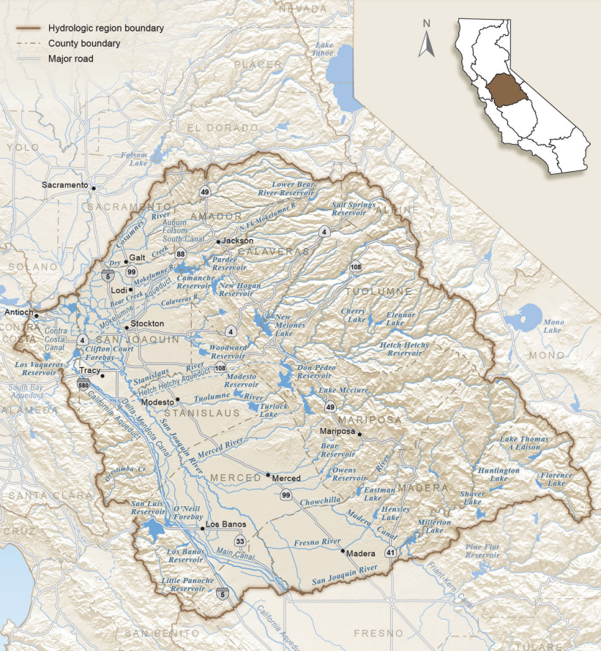

Notes: California Department of Water Resources, California’s Groundwater Update 2013

## Water portfolio of the San Joaquin River hydrologic region

We use data from the California’s Department of Water Resources Water Data Portfolios (California Department of Water Resources, n.d.) to obtain the supply portfolio for the 2002-19 period.[1] The data provided by DWR focuses on the type of supply provider, differentiating between water supplied by local suppliers from local sources, federal supplies (the Central Valley Project, or CVP), state supplies (State Water Project, or SWP), groundwater pumping, and categories that are not relevant in the SJR (Figure 2 top panel).

An important part of the CVP supplies and all of the SWP supplies in the valley come from exports from the Delta, which rely on water storage and flows not only from the SJR, but also importantly from the Sacramento River hydrologic region (Gartrell et al., 2017). But some CVP supplies also come from local reservoirs. Therefore, we used additional data for [CVP deliveries from the USBR](https://usbr.gov/mp/cvo/deliv.html) to separate DWR’s federal sources imported through the Delta from local sources (Figure 2 bottom panel).

Figure . Water supply portfolio by supply provider (top panel) and by water source (bottom panel) for the San Joaquin River hydrologic region

Source: Developed by the authors using data from DWR’s Water Data Portfolios

Notes: Top panel: As we only focus on direct supplies, we didn’t consider return flows and reuse. We also removed minor sources of water for the San Joaquin River hydrologic region. Local supplies refer to supplies developed by local utilities, federal to the Central Valley Project supplies including imports from the Delta and supplies from local sources in the valley, and SWP refers to the State Water project. Bottom panel: Local sources include CVP deliveries from the Madera Canal and Millerton Lake Branch, as well as deliveries from the Friant-Kern Canal, while imports include the remaining federal supplies plus the deliveries from the SWP.

As Figure 2 shows, total supplies vary significantly across years. The variability in total supplies comes especially from three different factors. First, during wet years (like 2011 or 2019) water availability in soils during the growing season increase, decreasing demands from external supplies. Second, higher temperatures (and other effects) increase evapotranspiration, raising water demands. Climate change is making this effect more and more important recently, although there is still some interannual variability. The assessment of the demand anomalies is trying to capture these two effects at least partially. Finally, the third factor that affects overall supplies is that droughts reduce overall water availability, reducing total supplies. This was especially relevant in 2014 and 2015.

But even more relevant the variability of total supplies is the variability for each of the supply sources. Surface supplies, both from local reservoirs and from imports, decline significantly during droughts—see 2014 and 2015 as the most relevant example—while groundwater pumping increases to mitigate these shortages.

## Estimating supplies, demands and shortages

As described earlier, we obtain estimated supplies from each water source based on the drought indicators, but we also account for changes in demands, and for unsustainable groundwater use to obtain the system indicator (Figure 3).

Figure . Drought indicators used to obtain the system drought indicator for the San Joaquin River hydrologic region

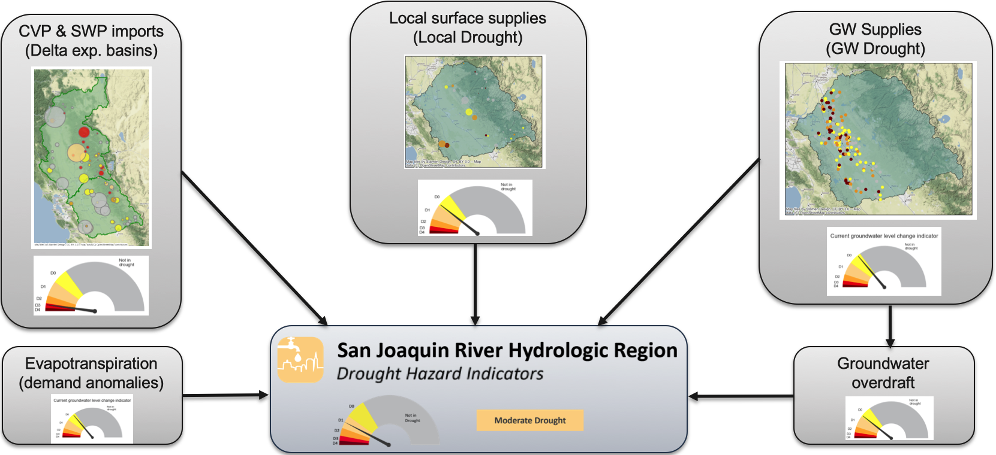

Notes: Developed by the authors.

### Estimating supplies using drought indicators

#### Local Surface Supplies

As we showed in the “*Methodology 1. User-oriented drought indicators in California*”, surface supplies are correlated with the Surface Water Drought Indicator. As Figure 4 shows, the relationship is roughly linear for dryer years, while above the median (percentile = 0.5) it plateaus, even declining a little for the wetter years. This might be explained because during wet years, precipitation directly helps maintaining soil moisture, reducing the need for additional irrigation in some parts of the year.

Figure . Relationship between local surface deliveries in the SJR and the Surface Water Drought Indicator

Source: Developed by the authors using the results of the SWDI and data from DWR’s Water Data Portfolios (updated with CVP data) for the local surface supplies. Data is for the water years 2002-19, excluding 2017.

Notes: The x-axis (SWDI) shows the average of the monthly SWDI over the water year, while the y-axis presents the surface deliveries over the water year.

Using this relationship, we adjusted a regression with two variables—SWDI and the logarithm of SWDI—that help fitting the non-linear relationship. For the 2002-19 period, we obtain a coefficient of determination for the local surface supplies, R2, of 0.76.

Figure . Comparison of actual local surface deliveries and estimated local deliveries

Notes: Developed by the authors using the results of regression.

#### Delta imports

Similarly, we correlate the deliveries from Delta imports with the SWDI of the Delta exporting basins. As Figure 6 shows, the relationship is quite clear, although non-linear. The plateau can be explained in this case because of infrastructure constraints—there is only so much pumping and conveyance capacity in the CVP and SWP.

Figure . Relationship between Delta imports in the SJR and the Surface Water Drought Indicator of the Delta exporting basins

Source: Developed by the authors using the results of the SWDI and data from DWR’s Water Data Portfolios (updated with CVP data) for Delta imports. Data is for the water years 2002-19, excluding 2017.

Notes: The x-axis (SWDI) shows the average of the monthly SWDI over the water year, while the y-axis presents the surface deliveries from Delta imports over the water year.

Analogously to the previous section, we adjusted a regression with two variables—SWDI of the exporting basins and the logarithm of SWDI of the exporting basins—that help fitting the non-linear relationship. For the 2002-19 period, we obtain a coefficient of determination for the deliveries from Delta imports, R2, of 0.77. Figure 7 shows the result of the adjustment.

Figure . Comparison of actual deliveries from Delta imports and estimated deliveries from Delta imports

Notes: Developed by the authors using the results of regression.

#### Groundwater pumping

Groundwater pumping is used as a backup source in the SJR, so while drought conditions can affect its use (for instance limiting pumping where groundwater declined affecting wells), actually it is used more during droughts to mitigate surface water shortages. Therefore, this management decision has to be considered.

Figure 8 shows the how especially during water with low surface deliveries, pumping increases significantly, although the relationship is less clear in “normal” years. To address this limitation, we also include the relationship between the groundwater pumping indicator—which represents the annual change in groundwater level, informing about the intensity of annual groundwater pumping—and annual groundwater deliveries. In this case, the relationship is not so clear for lower values of the groundwater pumping indicator, but it performs better in years with lesser changes of groundwater levels.

Figure . Relationship between surface deliveries and groundwater pumping (top) and between the groundwater pumping indicator and groundwater pumping (bottom)

Source: Developed by the authors using the results of the DWR’s Water Data Portfolios and the Groundwater Pumping Indicator. Data is for the water years 2002-19, excluding 2017.

Notes: Top panel: the x-axis shows the sum of the surface deliveries both from local sources and Delta imports. Bottom panel: the x-axis shows the annual average of the monthly groundwater pumping indicator, which shows the annual change in groundwater levels, which is correlated with pumping intensity.

Therefore, for groundwater pumping we use a two-variable regression, including the estimated surface deliveries (sum of local surface supplies and Delta imports) obtained in the previous sections and the annual average of the groundwater pumping indicator. With these two variables, and for the 2002-19 period, we obtain a coefficient of determination for groundwater deliveries, R2, of 0.88. Figure 9 shows the result of the adjustment.

Figure . Comparison of actual groundwater deliveries and estimated groundwater deliveries

Notes: Developed by the authors using the results of regression.

#### Combined supplies from different sources

When combining the three sources of water we can compare the actual total deliveries with the results of the regression (Figure 10). The figure shows a good fit for total deliveries, but what is also important, fits the management decisions by adjusting groundwater pumping to the reduction in surface deliveries and vice versa.

Figure . Comparison of actual deliveries and estimated deliveries from the different sources

Notes: Developed by the authors using the results of regressions

### Estimating demand anomalies

In places where water is mostly used for water irrigation like in the SJR, differences in evapotranspiration can impact crop demands significantly (Albano et al., 2022). This means that similar deliveries can irrigate more or less acreage depending on the evapotranspiration. Therefore, it is important to account for the role of warming-induced drought stress.

To account for changes in evapotranspirative demands, we obtain the deviation (in percentage) of the annual evapotranspiration with respect to the average evapotranspiration (Figure 11).

Figure . Deviation in annual evapotranspiration

Notes: Estimated by the authors as the ratio of the annual evapotranspiration in the water year with respect to the average annual evapotranspiration

Then, we obtain the warming-induced change of demands by multiplying this deviation by the average annual demands. Finally, because supplies are given as estimated in the previous sections, we will obtain a change in what we call *effective supplies*: reductions in evaporative demands will represent an increase in *effective supplies*, and increases in evaporative demands will impact *effective supplies* negatively.

Equation 4

Following Equation 4 we can adjust the actual supplies to account for the deviation in evapotranspiration (Figure 12). In the figure we can see how in wetter years, such 2011, the effective supplies are greater than the actual supplies, while in warmer years (like 2014 and 2015), effective supplies decrease.

Figure . Comparison of estimated supplies with effective supplies, accounting the ET deviations

Notes: Estimated by the authors using the estimated supplies and the ET deviation

### Accounting for changes in groundwater storage

While surface water conditions affect directly surface deliveries, management decisions—in which pumping increases in dry years to mitigate surface water shortages—create a disconnect between drought conditions and water deliveries. These changes in groundwater storage help identifying which groundwater deliveries are used to respond to drought conditions from groundwater deliveries in normal and wet years.

To account for these changes we obtain a linear relationship between the annual groundwater supplies from the supply portfolio and the annual changes in groundwater elevation—obtained to calculate the groundwater pumping intensity indicator (Figure 13). Then, and assuming that the intercept of the linear adjustment with the y-axis represents the level of sustainable groundwater use, we obtain the changes in groundwater storage as the difference of the estimated groundwater supplies with the value of the intercept—values greater than the intercept will represent groundwater depletion, while values below this value will represent an increase in groundwater storage (Figure 14).

Figure . Relationship between annual groundwater supplies and annual change in groundwater elevation in the San Joaquin River hydrologic region

Notes: Calculated by the authors using the data from DWR’s water portfolios and from changes in groundwater elevation obtained from DWR’s Periodic Groundwater Levels dataset

Figure . Changes in groundwater storage in the San Joaquin River hydrologic region

Notes: Calculated by the authors

Finally, and similarly as we did for accounting for demand anomalies, we correct the annual supplies to account for the changes in groundwater storage (Figure 15). It is important to note that the actual deliveries do not change because incrementing groundwater use is a management decision to mitigate drought impacts. But by accounting for changes in groundwater storage, we can actually measure how droughts are causing this increase in pumping. This method can help also internalizing some other drought impacts—such as wells running dry by changes in groundwater levels, or the potential losses caused by the future reduction in groundwater availability.

Figure . Comparison of estimated supplies with effective supplies, accounting for changes in groundwater storage

Notes: Calculated by the authors using the estimated supplies and the changes in groundwater storage

### Estimating shortages

After estimating the total supplies as the sum of supplies from different sources, we obtain the final effective supplies by accounting for demand anomalies and changes in groundwater storage (Figure 16). Note how especially changes in groundwater storage, but also demand anomalies, change the annual distribution of estimated supplies and final effective supplies. While in the estimated supplies is difficult to see the differences between drought vs non-drought years, final effective supplies highlight clearly the drought years—especially 2014 and 2015, but also 2008 and 2009.

Figure . Comparison of estimated supplies with final effective supplies, accounting for demand anomalies and changes in groundwater storage

Notes: Calculated by the authors using the estimated supplies and the estimated demand anomalies and changes in groundwater storage

To estimate shortages, a simple approach is to assume that deliveries are maximum when there are no drought restrictions, and annual shortages are calculated as the difference from the maximum deliveries. Figure 17 shows the estimated shortages, calculated as the annual effective deliveries with respect to the maximum annual effective deliveries, which are 2011 deliveries (one of the wettest years on the series).

Figure 17. Estimated annual shortages in the San Joaquin River hydrologic region

Notes: Calculated by the authors using the estimated final effective

## Obtaining system drought indicator for any date

We have obtained annual shortages for years with water deliveries from DWR’s water balance dataset using the drought indicators developed in Methodology 1. Therefore, we can extrapolate this methodology to obtain drought conditions and shortages for any point in time. Using these methods, we can estimate now supplies from each of the sources (Figure 18), demand anomalies (Figure 19), and changes in groundwater storage (Figure 20) to finally obtain effective deliveries (Figure 21) and system shortages (Figure 22).

Figure 18. Estimated annual deliveries from each source since 1991

Notes: Calculated by the authors

Figure 19. Estimated demand anomalies since 1991

Notes: Calculated by the authors

Figure 20. Estimated changes in groundwater storage since 1991

Notes: Calculated by the authors

Figure 21. Estimated final effective deliveries since 1991

Notes: Calculated by the authors

Figure 22. Estimated system shortages since 1991

Notes: Calculated by the authors

Although in the previous figures we have shown the annual average of the deliveries and shortages, we can obtain these values for any month in the dataset. Then, to obtain the system drought indicator we will use a similar approach than we used in Methodology 1, obtaining the distribution of shortages for each month, and then obtaining the monthly percentile of these shortages, to be consistent with the drought indicators obtained previously. Figure 23 show the system drought indicator and its associated shortages.

Figure 23. Drought system indicator and water shortages in the San Joaquin River HR for every month since 1991

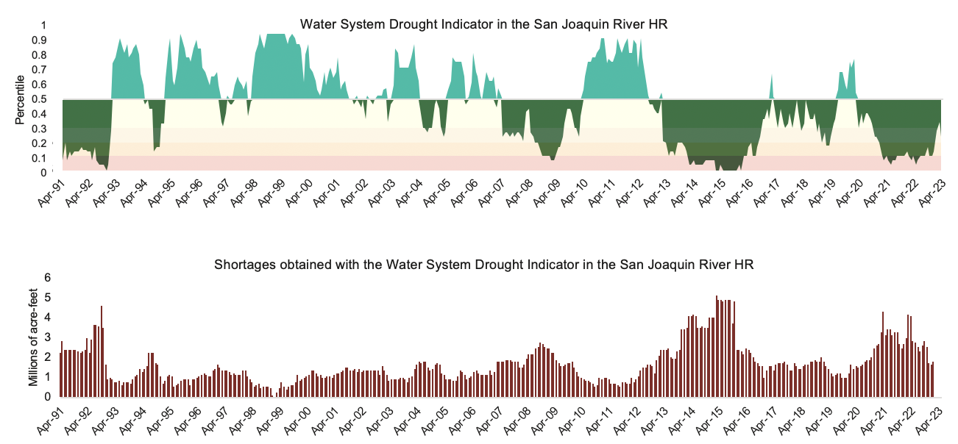

Notes: Calculated by the authors

# Conclusions

With this methodology, we have developed a drought indicator to be used in water systems with complex supply portfolios, taking into consideration management decisions—including the overuse of groundwater resources.

Using drought indicators developed in Methodology 1 to understand water deliveries and management decisions, we obtained the system drought indicator for a number of years (2002-2019) where we had detailed delivery data from DWR water balance dataset. But because we based our approach in indicators from data readily available, we could extrapolate the methodology to any month, obtaining system water shortages and its corresponding water system drought indicator.

Although we have applied the methodology to the San Joaquin River hydrologic region—an agricultural region—this method could be applied to any water user with delivery data available—being able to obtain sectoral water drought indicators. In California, this is especially relevant for cities and agricultural districts with complex supply portfolios.

# References

Albano, C. M., Abatzoglou, J. T., McEvoy, D. J., Huntington, J. L., Morton, C. G., Dettinger, M. D., & Ott, T. J. (2022). A Multidataset Assessment of Climatic Drivers and Uncertainties of Recent Trends in Evaporative Demand across the Continental United States. *Journal of Hydrometeorology*, *23*(4), 505–519. https://doi.org/10.1175/JHM-D-21-0163.1

California Department of Water Resources. (n.d.). Water Data Portfolios. Retrieved June 23, 2023, from https://water.ca.gov/Programs/California-Water-Plan/Water-Portfolios

Gartrell, G., Mount, J., Hanak, E., & Gray, B. (2017). A new approach to accounting for environmental water. *Public Policy Institute of California*.

Hanak, E., Escriva-Bou, A., Gray, B., Green, S., Harter, T., Jezdimirovic, J., et al. (2019). Water and the future of the San Joaquin Valley. *Public Policy Institute of California*, *100*.

Redmond, K. T. (2002). The depiction of drought: A commentary. *Bulletin of the American Meteorological Society*, *83*(8), 1143–1147.

1. Data for 2017 is missing in DWR’s database